**National University of Computer and Emerging Sciences**



Laboratory Tasks 02

*for*

# Web Engineering

*Instructor: Saqib Ameer Email:* [*saqib.ameer@nu.edu.pk*](mailto:saqib.ameer@nu.edu.pk)

# Spring 2024

**FAST School of Computing**

## Lab Task 1:

Create a slider image webpage must including following when user click the dots which is shown in image after pressing images changed.

For this images are given to you make slider of 4 images which also embed in 2nd task.

Make sure to fulfill the following requirements.

1. Add images .
2. Make buttons like radio button for pressing to change the image.
3. You can use two methods
   1. Use the keyframes css property for animations
   2. Use the div classes and id’s and CSS property with name

#img1:checked ~ .m1 m1 is id name #img1 is class name

1. Prefer Method a using keyframes animations
2. Just use html5 and css no use of javascript or jquery for making slider.



## Lab Task 2:

Make a replica of the mentioned screen shot of the landing page. Structure of the website is:

In this task you need to follow these instructions

1. Make a Header which contains
2. Logo of the Website
3. Navigations Links with hovering properties
4. Account manage icons with search bar
5. Make a single div with name home then make 3 to 4 divs to manage this page
6. First div with name mainslide1 which contains h1 tag with span change the color of the specific word and one button with arrow sign icon
7. In this same div use the property of nth-child(1) and nth-child(2) to manage the image in the right side with rounded shape.
8. Make another div to manage the news like given in the screenshot.
9. Must use the Vedio and Audio tags to manage the audio and vedio news and most important vedio of news should be fixed on the top not change with the scrolling fixed.
10. In last use the iframes to manage the map location of the headoffice like address through google map.
11. Also make the form to Add new news using new page or the same page.

<!DOCTYPE html>

<html lang="en">

<head>

<meta charset="UTF-8">

<meta name="viewport" content="width=device-width, initial-scale=1.0">

<link rel="stylesheet" href="styles.css">

<title>Latest News Manage</title>

</head>

<body>

<header>

...

</header>

<section class="home">

<div>Mainslide1

Main slide2

Mainslide3

</section>

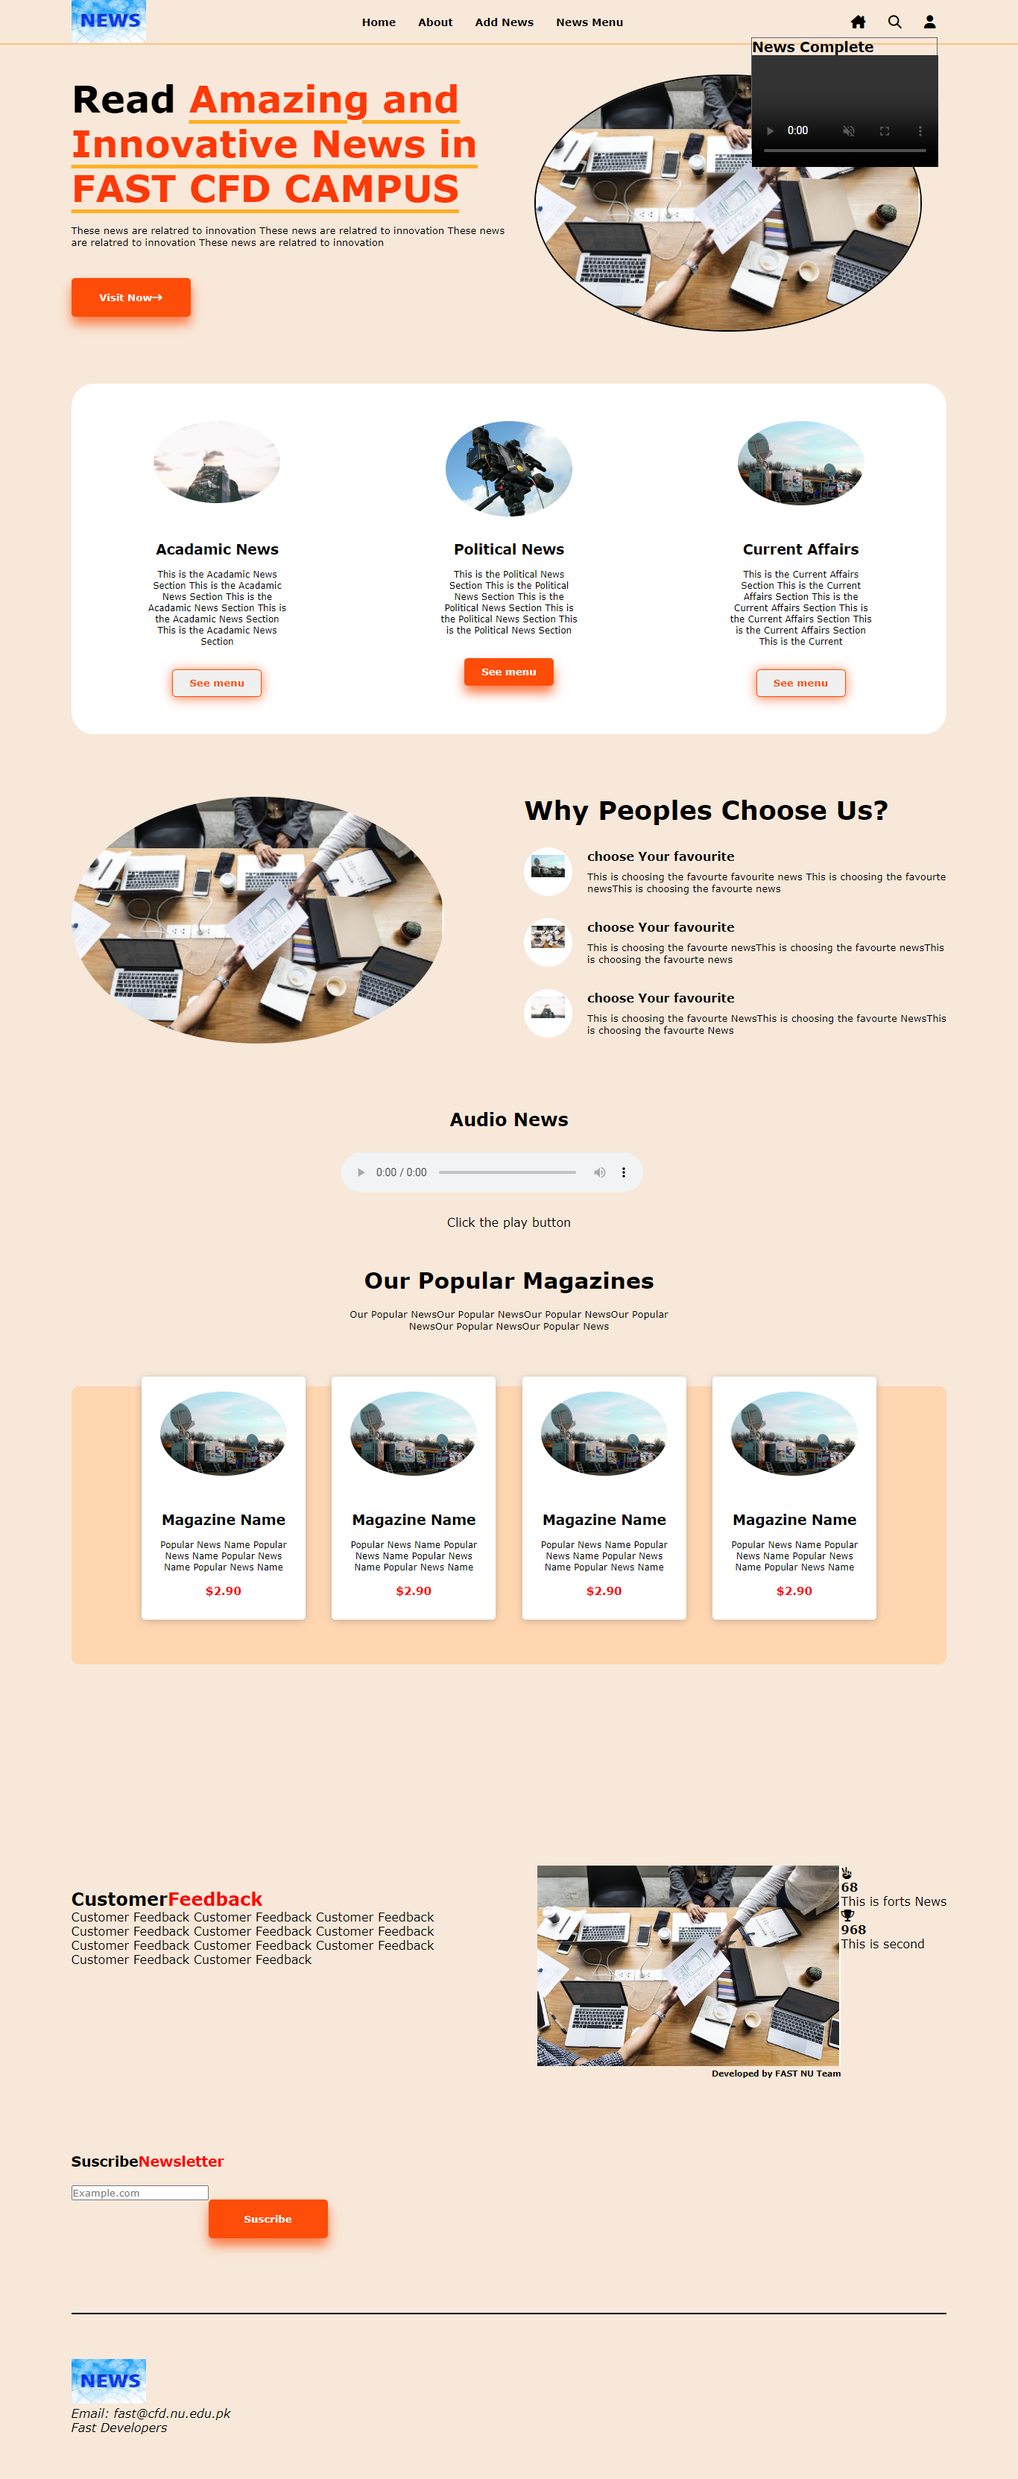

The page should be responsive. Use CSS properties in proper way and try to use classes instead of id. All items of header and buttons should be clickable.

**Visit Link to Practice More:** https://www.w3schools.com/html/html

**You are done with your exercise(s), make your submission on Classroom.**

**BEST WISHES**